Greenhouse Effect Name: _____________________________________
Open the link https://phet.colorado.edu/sims/html/greenhouse-effect/latest/greenhouse-effect_all.html
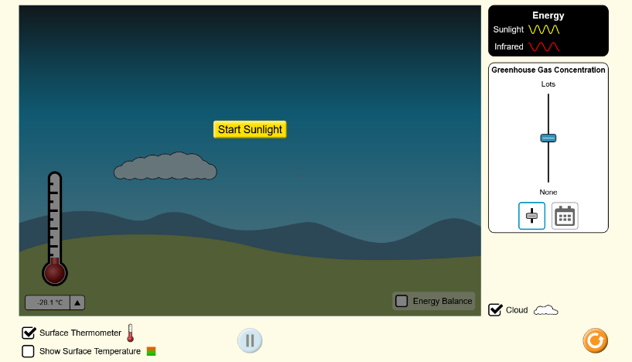
Observe the relationship of UV (sunlight) to IR (infrared light). Before starting the simulation make sure that the Thermometer and Cloud are turned on. Click the button “Start Sunlight”. Use the Toggle button “Greenhouse Gas Concentration” to decrease and increase the amount of CO₂.
- How does the temperature change when you decrease the CO₂?
________________________________
- How does the temperature change when you increase the CO₂?
________________________________

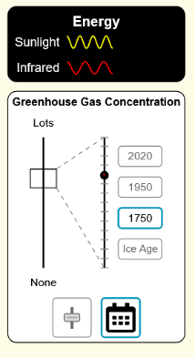
Change the Toggle button “Greenhouse Gas Concentration” to the Calendar View. Complete Table 1
Date | CO2 Concentration | Surface Temperature
Ice Age
1750
1950
2020

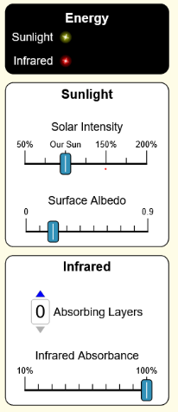
Now Go to the Layer Model To look at the effect of multiple layers in an atmosphere Start the simulation with 0 Layers. Complete Table 2
Absorbing Layers | Surface Temp | Layer 1 Temp | Layer 2 Temp | Layer 3 Temp
0
1
2
3

3. What is the effect on Surface Temperature when additional Absorbing Layers are added to the atmosphere?

